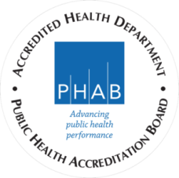
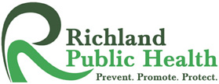
Richland Public Health
Environmental Division
555 Lexington Avenue
Mansfield, OH 44907
www.richlandhealth.org
(419)774-4520

Water Pollution Control Loan Fund
2020 Application for Assistance Information Factsheet
Who is eligible?

Applicant(s) must meet the following program criteria:

1) Household income per the program criteria listed below.

2019 U.S. Department of Health & Human Services Poverty Guidelines
Persons in Family/Household | 100% Poverty Guideline  (100% Assistance) | 100% - 200% Poverty Guideline  (85% Assistance) | 200-300% Poverty Guideline (50% Assistance)
1 - 4 | $25,750 | $51,500 | $77,250
5 | $30,170 | $60,340 | $90,510
6 | $34,590 | $69,180 | $103,770
7 | $39,010 | $78,020 | $117,030
8 | $43,430 | $86,860 | $130,290
* For families with more than eight (8) persons, add $4,420 for each person.

2) Sewage system must be failing and verified by Richland Public Health (RPH)
3) Applicant must be the homeowner
4) Property taxes must be current/paid
5) Rental property, new-build homes and homes advertised for sale are not eligible
How Homeowners Are Selected To Participate?

- Severity of system failure will be a primary factor
- Financial need
- Order of the receipt of applications also considered

Does it cost anything to apply?

- There is NO cost to apply for the program.

Additional Information:

- Applications accepted through the duration of grant program, or until all funding is expended.
- RPH will conduct a site visit to evaluate status of the sewage treatment system failure or verify dwelling need of connection to existing sanitary sewer.
- Applicants who receive 85% or 50% funding must pay the balance in full before work can begin.
- Homeowner does not select the contractor, RPH contracts with local, registered contractors selected through a competitive bidding process.
- Homeowner must allow RPH, contractors and OEPA representatives to enter property and make inspections.
- Sewage treatment system repair could create a dirty environment and damage to your lawn.
- RPH is required to inspect all sewage treatment systems that have been altered or installed within 12 months and thereafter.
- Before any work can begin, permits must be obtained in advance from RPH.

Questions? Please refer to the RPH website (www.richlandhealth.org) for further information
or contact our office at (419)774-4500.

