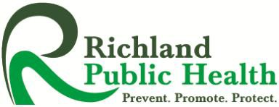 VOLUNTARY AFFIRMATIVE ACTION SURVEY FORM
To All Applicants:

Your name MUST NOT appear on this form. The data requested is for statistical and record-keeping purposes only. This form will not be used in evaluating your application for any position.

Richland Public Health has a commitment to Equal Employment Opportunity/Affirmative Action. There will be no discrimination on the basis of race, color, age, sex, religion, national origin, handicap, veteran status, marital status, non-job related medical conditions or disability that can be reasonably accommodated.

- Date of
Application: Month Day Year

- Position Applied For:

- Birth Date: Month Day Year

- Sex: Female Male

- Ethnic Origin – Check one of the following
White Black Hispanic Asian or Pacific Islander
American Indian or Alaskan Native

- Veteran: Yes No

- Disabled: Yes No

- How did you hear about the position for which you have applied?
Newspaper Advertisement

Friend

Health Department Employee

Ohio Bureau of Employment Services

Community Action Agency

Walk-In

Other, Explain

C:\Users\Anita Douville\Documents\FORMS\RPH Affirmative Action Survey.docx

